Situation Report on Nepal’s Agrifood Systems May 2023 | Bulletin Number 6

# Key messages

**Overall assessment:** In April 2023, Nepal experienced high prices for both food and non-food items. The inflation rate for food and beverage prices on a year-on-year basis stood at 6.9 percent. Although this is lower than the 7.4 percent recorded in March and April 2022, it still signifies a considerable rise in the cost of food from its already elevated levels. Moreover, the consumer price index (CPI) exhibited a more substantial increase compared to the wage rate index, with a 7.8 percent rise versus

6.1 percent. As a result, informal sector employees faced a decline in their real wages.

**Cereal prices continue to be high:** Despite a satisfactory wheat harvest at the end of the winter season in March and April, there has been no significant decrease in the price of staple foods in Nepal. From March to April 2023, there was only a marginal increase of 0.11 percent in the price of cereals, which were already at high levels. Both unprocessed grain and cereal products were 13.7 percent more expensive in April 2023 compared to the same month in 2022. The persistently high prices of staple foods disproportionately affect the poorest families, as they tend to allocate a larger portion of their household budget to these items. Nepal remains partially reliant on India's exports of rice and wheat, and the imposition of taxes and restrictions on these commodities’ exports by India may be driving up cereal prices in Nepal.

**Agricultural and industrial laborers experienced a decline in their real wages:** The average wage rates for agricultural laborers remained stagnant between February and March 2023. However, during the same period, the consumer price index (CPI) experienced a 1.1 percent increase. The wage indices for semi-skilled, unskilled industrial laborers, and construction workers also grew at a slower pace compared to the CPI. This decline in real wages has the potential to push workers in the informal sectors and their families into temporary poverty. Our analysis of data from a representative sample of households in Nepal indicates that most impoverished households lack access to safety net programs that could provide some protection against the adverse effects of rising prices and stagnant incomes.

**Vulnerability tied to El Niño – Southern Oscillation (ENSO):** Global forecasts indicate a probable strengthening of El Niño weather patterns in 2023. This has raised concerns among policymakers and traders about the impact of drier conditions on crops, particularly rice, during the monsoon season. Without appropriate and timely irrigation measures in place to address these dry conditions, Nepal could experience a reduction in sown area and crop yields. However, the extent of this impact will depend on the timing of the monsoon onset in relation to El Niño patterns.

In addition, El Niño may lead to warmer weather in the latter part of 2023, which can adversely affect both late-sown summer crops and early-sown winter season crops by causing heat stress. Even if the negative weather shocks associated with El Niño do not materialize, concerns among farmers,

traders and in some levels of government may result in policy and business actions that sustain high prices for staple foods in Nepal well into the latter half of 2023.

# Macroeconomic trends and implications for household economic welfare

**Key messages:** The year-on-year inflation in Nepal's Consumer Price Index (CPI) increased slightly from 7.4 percent in February and March to 7.8 percent in March and April of 2023. This inflationary trend has affected a wide range of commodity prices. For instance, food prices experienced a 6.9 percent increase, while non-food prices rose by 8.4 percent. High prices of cereals, cereal products, milk, milk products, and eggs have been significant contributors to inflation. Importantly, increases in prices have not been matched with increasing wage rates, which have remained stagnant for men but have declined for women agricultural laborers (Figure 1).

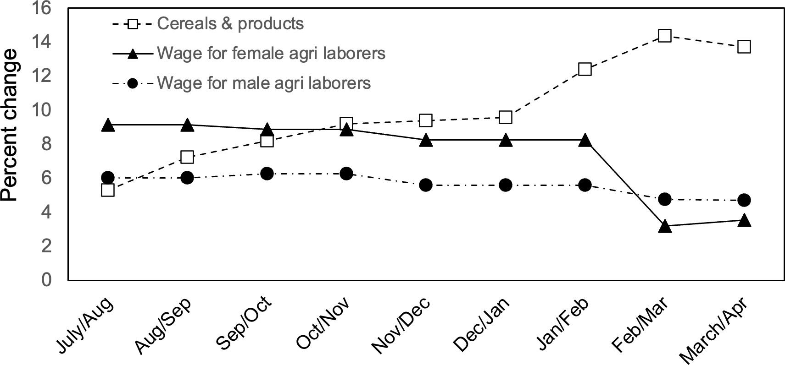

***Figure 1.*** *Percentage change in price indices and wage rates for men and women compared to the same period in the previous year in Nepal in 2022-2023.*

Despite the implementation of a tight monetary policy with high interest rates and a deceleration in economic growth, inflation is expected to remain high in the coming months. This is primarily due to sustained high commodity prices, partially influenced by the ongoing war in Ukraine. Furthermore, the continuation of export restrictions on coarse rice and wheat by India, along with concerns about a drier and warmer summer, may have similar effects on food prices in Nepal.

**Remittance inflows:** The total remittance inflow from July 2022 to March 2023 in Nepali Rupees increased by 24.2 percent compared to the total inflow between July 2021 and February 2022. In US Dollars, the remittance flow was 13.9 percent higher during the same period. This growth in remittance inflows coincides with a significant rise in the number of new Nepali workers seeking foreign employment or renewing their approvals. In the first nine months of 2022-23, this number reached 0.6 million, doubling the figure from the same period in 2021-22. The strong growth in remittance inflows has positive effects for Nepal's balance of payments, helping to reduce deficits.

Additionally, it provides a cushion for Nepali households, helping them mitigate the impact of a slowing economy.

# Recent price fluctuation in food commodities and agricultural inputs

**Rice and wheat**

**Key message:** In March 2023, the national average price of coarse rice increased by 4.7 percent compared to the previous month and was 2.4 percent higher than the same month in the previous year. Specifically in Western Nepal, the price of rice rose by 2.7 percent compared to February 2023 and by 1.1 percent compared to March 2022.

**Wheat:** The price of wheat flour saw a huge jump in March 2023. Its national average price was 37.2 percent higher than the previous month and 34.9 percent higher than in March 2022. Western Nepal also witnessed similar spike in the prices of wheat flour. Reports of crop damage due to untimely rains in wheat growing areas of India may have contributed to the increase from already high levels.

**Policy, trade and climate risks:** Due to concerns about food inflation leading up to the parliamentary elections in April-May 2024, the Government of India is unlikely to ease the restrictions on rice and wheat exports. The situation is further exacerbated by the fact that India's public procurement of wheat during the winter of 2023 fell well below the target for the second consecutive year. Additionally, Indian policymakers appear to be apprehensive about the potential strengthening of El Niño later in the year (Figure 2), which could impact the country's food production and supplies.

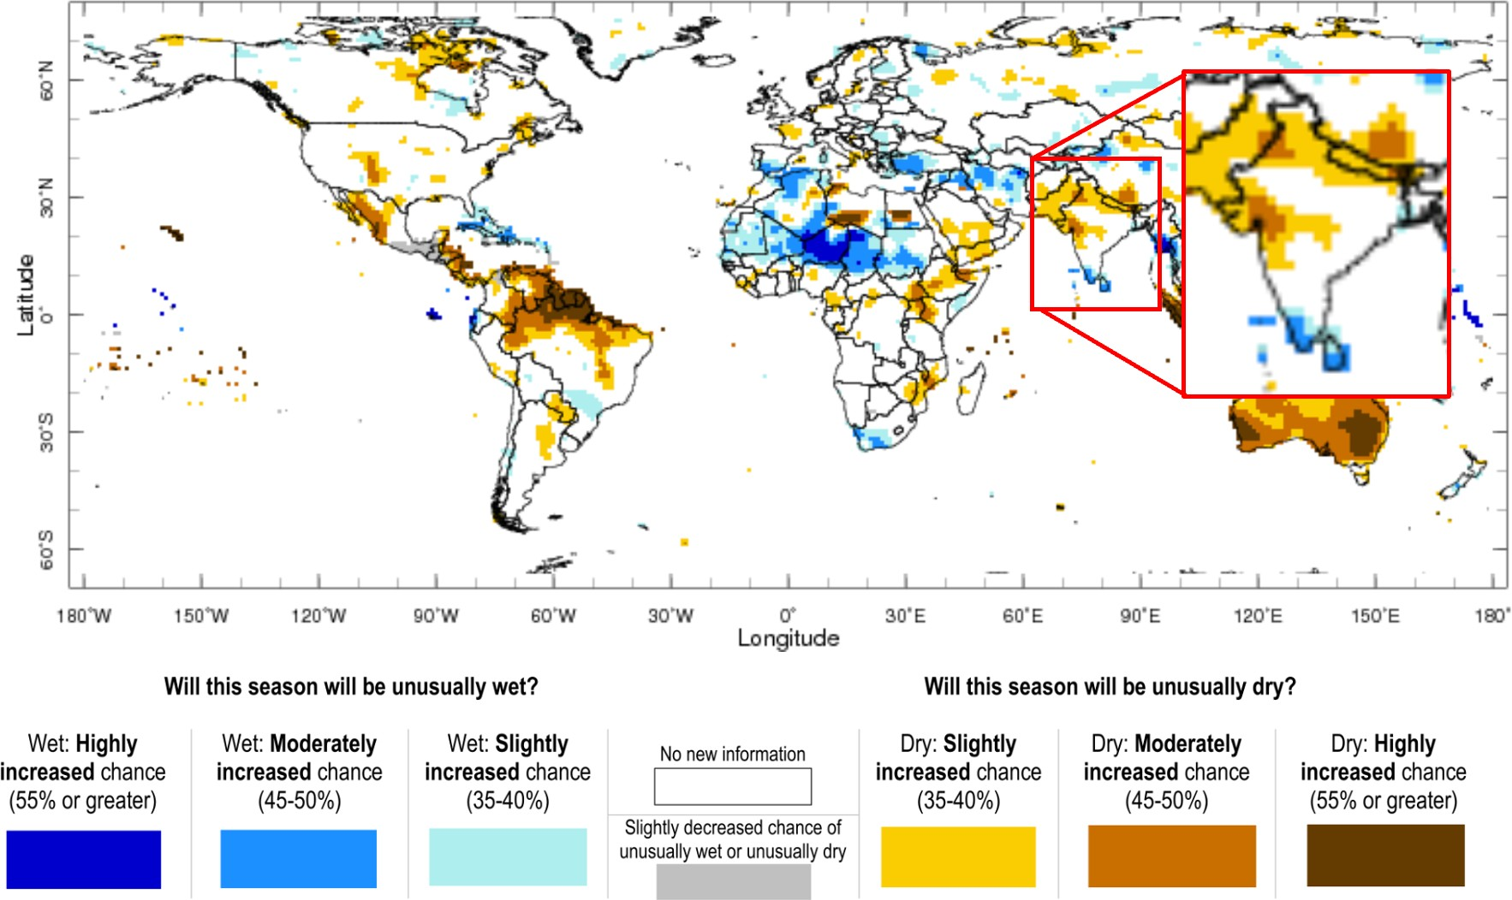

***Figure 2.*** *Locations in Asia where the El Niño – Southern Oscillation could result in unusually dry weather in June through August of 2023, potentially affecting rice production across northern South Asia including Nepal. Data courtesy of the International Institute for Climate and Society.*

If the Government of India continues with its cautious export policies for rice and wheat, staple prices in Nepal are likely to remain high. These policies contribute to the sustained high prices of these commodities in Nepal.

# Horticultural and select fruit products

**Key messages:** After experiencing a significant decline in recent months, vegetable prices began to rise again in March/April. The vegetable price index witnessed an increase of nearly 10.0 percent from February/March to March/April 2023. On a year-to-year basis, there was a 1.0 percent increase. Vegetables constitute approximately 5.5 percent of the average household expenditure and 12.6 percent of the average food expenditure in Nepal. Therefore, a substantial rise in vegetable prices is likely to have an impact on the dietary quality of poor households in particular.

**Fruits:** In comparison to the previous month, the average price of fruits saw a 3.3 percent increase, and it was 11.0 percent higher compared to the same period in 2022. The price of bananas experienced a sharp rise from the previous month, and there was also a noticeable increase in the price of apples. However, in terms of average household food expenditure, fruits have a smaller share, accounting for 4.7 percent. Consequently, the impact of price increases in fruits on the family budget will be relatively smaller compared to vegetables.

# Potato

**National prices:** The national average price of potatoes remained steady between February and March 2023, while it increased by 2.0 percent in March 2023 compared to the same period the previous year. In Western Nepal, the price of potatoes rose by 1.8 percent compared to the previous month and by 2.3 percent compared to the previous year.

# Tomato

**National prices:** Nationally, there was a 5.5 percent decrease in tomato prices between February and March 2023. In Western Nepal, tomato prices experienced a further decline of 12.5 percent in March, following a significant drop of 24.5 percent between January and February. Tomatoes are known for being challenging to transport and store, which contributes to sharp price variations over time and across different locations. Investments in shorter value chains, effective postharvest technologies and cold storage will be needed to improve Nepal’s tomato production and marketing systems.

**Sufficient and reliable data are lacking** in addition to infrastructure and market system development as described above, investments in data systems for horticultural crops are crucial in Nepal. Currently, there is a lack of reliable public data on production and farm harvest prices of horticultural crops that are easily accessible to the public. This poses a challenge when trying to make reliable assessments regarding the impact of consumer price volatility on producers. Additionally, estimating the impact of production shocks on consumer prices is difficult without resorting to speculative approaches that may not be scientifically sound. Therefore, efforts are necessary to develop robust data and information systems specifically tailored for these overlooked commodities.

# Banana

**Price changes nationally and regionally:** National average banana price continued to rise in March. Prices were 9.3 percent higher in March 2023 than the previous month and 14.3 percent higher than a year ago. In Western Nepal, banana prices were 7.9 percent higher compared to February 2023 and 6.3 percent higher than the year before. Bananas are an important source of micronutrients including potassium, vitamin C, and vitamin B6. High prices could result in decreases in the consumption of these important nutrients for households not producing bananas. This could contribute to micronutrient deficiencies within poorer households.

# Edible oils

**Key messages:** Animal fat and edible oils play a crucial role in human diets. They provide essential fatty acids and fat-soluble vitamins and are important for human health and well-being. The downward trend in the price of edible oils in Nepal persisted in March. The national average price of mustard oil decreased by 7.8 percent from February to March 2023, while the price of soybean oil saw a decline of 5.0 percent. In comparison to the same period in 2022, mustard oil was 13.9 percent less costly and soybean oil was 11.0 percent cheaper in March 2023. According to public data in Nepal, the price index of animal fat and edible oils recorded an 8.1 percent decline in March/April 2022 and 2023, indicating a consistent decrease over the years. The decrease in the price index of these food items suggests that poor consumers may find them more affordable, which is likely to be beneficial, as long as edible oils are part of their balanced diets.

# Agricultural inputs and access to finance

**Key messages:** Certainty regarding fertilizer prices and availability continues to be a concern for farmers and input dealers in Nepal. The rising interest rates, implemented as a measure to control inflation, have led to increased borrowing costs and a slowdown in credit flow to farmers and small businesses.

**Fertilizers:** In less than a month and if sufficient rains commence, the sowing of paddy will commence in parts of Nepal. Unfortunately, DAP and Potash fertilizers were either unavailable or only accessible in limited quantities in Western Nepal. Moreover, even Urea, which is supposed to be sold at a controlled price of NPR 14 (0.11 USD) per kg, is currently being sold at higher rates ranging from NPR 23-27 (0.17-20 USD) per kg. Despite the Government of Nepal's decision to import additional fertilizer supplies, farmers and cooperatives are still facing a scarcity of fertilizers. This situation has been reported by multiple sources, indicating a gap between the intended import measures and the actual availability of fertilizers on the ground.

**Policy changes:** The Government of Nepal has recently reversed its decision, which was made on March 13th of 2023, to reduce subsidies on Urea, DAP, and Potash fertilizers. As a result, the official retail prices of these three fertilizers will remain unchanged. While decisions are anticipated to mitigate the challenges faced by poor farmers, it is also anticipated to increase government expenditure on fertilizer subsidies and constrain foreign currency reserves, compared to the original plan.

# Energy

**Key messages:** The price of diesel in Nepal witnessed a significant decrease from NPR 175 (USD 1.31) per liter in February 2023 to NPR 165 (USD 1.25) per liter in March and April. In May, diesel prices further dropped to NPR 155 (USD 1.17) per liter. This sharp decline in diesel prices, particularly just before the paddy season, is expected to bring relief to farmers. The reduced diesel prices may lead to a potential reduction in rental rates for machines used in land preparation and irrigation. This could alleviate some financial burden on farmers by making these services more affordable during the upcoming summer rice season.

# Acknowledgements

This work is supported by the USAID/Nepal-funded Cereal Systems Initiative for South Asia (CSISA) ‘Building food system resilience to global supply chain and climate shocks in Nepal’ Activity and the CSISA Phase III project supported by USAID-Washington. CSISA’s work in Nepal is also strategically aligned with the One CGIAR Regional Integrated Initiative Transforming Agrifood Systems in South Asia (TAFSSA). The project is led by CIMMYT and implemented jointly with IFPRI, IRRI, and IWMI. International Development Enterprises (iDE) is another key partner of CSISA in Nepal and Bangladesh.

# Data sources

Data sources for this brief includes the World Food Program WFP for food prices, globalpetrolprice.com for fuel prices, the Nepal Rastra Bank for the CPI, budget shares, remittance flows, and other macroeconomic data, USDA reports for India’s export outlook, and the World Bank Household Risk and Vulnerability Survey (HRVS) for household occupations and reliance on remittance income in addition to price information and field reports provided by USAID/Nepal’s Implementing partners, notably the Nepal Seed and Fertilizer (NSAF) Project and KISAN II.

# Disclaimer

The content and opinions expressed in this paper are those of the authors and do not necessarily reflect the views of USAID or CGIAR and shall not be used for commercial purposes.

# Suggested citation

Kishore, A., Minot, Parajuli, R., Koirala, P., Krupnik, T.J. 2023. Situation Report on Nepal’s Agrifood Systems (May 2023 Bulletin Number 6). The Cereal Systems Initiative for South Asia (CSISA) and Transforming Agrifood Systems in South Asia (TAFSSA). Kathmandu, Nepal.

*This publication is licensed for use under a Creative Commons Attribution 4.0 International License (CC BY 4.0). To view this license, visit https://creativecommons.org/licenses/by/4.0.*